IP Address Scheme Design and Static Routing

By Vlad R.

# 1.Introduction

The designed network provides connectivity between multiple labs and offices across three main locations: Building A, Building B, located at Richmond Site, and the Sunbury Site **(see Figure 1)**. The network includes diverse subnets catering to different device requirements and routing connections across various backbones to enable seamless communication. The topology is a hierarchical star topology with a central backbone, carefully crafted with routers, switches, and a WAN connection to support internal and external communications. The internet connection is facilitated via a dedicated server connected to the global network.

Figure 1

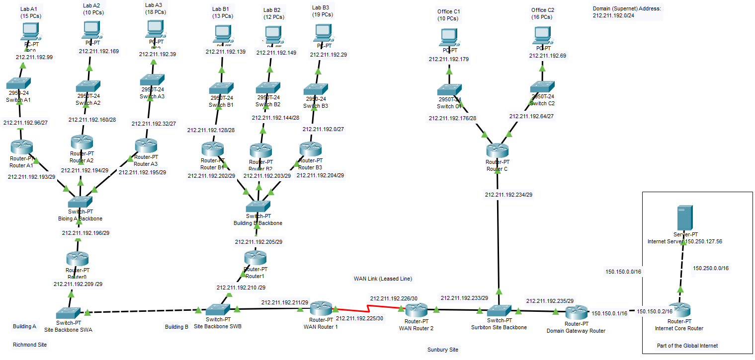

# 2. IP Addressing Scheme

The IP addressing scheme utilizes the 212.211.192.0/24 domain, employing Variable Length Subnet Masking (VLSM) to optimize IP address allocation. Each lab and backbone has been assigned a unique subnet to prevent conflicts and ensure efficient routing. The IP addresses were calculated and assigned based on the required host count in each subnet, ensuring sufficient IPs while conserving unused space. VLSM allocation minimizes wastage and accommodates future scalability.

Network Address List

212.211.192.0/27 - Lab B3

212.211.192.32/27 - Lab A3

212.211.192.64/27 - Office C2

212.211.192.96/27 - Lab A1

212.211.192.128/28 - Lab B1

212.211.192.144/28 - Lab B2

212.211.192.160/28 - Lab A2

212.211.192.176/28 - Lab Office C1

212.211.192.192/29 - Building A Backbone subnet

212.211.192.200/29 - Building B Backbone subnet

212.211.192.208/29 - Router 0, WAN Router 1 and Router 1’s interfaces towards Site Backbones (SWA, SWB)

212.211.192.224/30 - WAN Router Link (WAN Router 1 to WAN Router 2)

212.211.192.232/29 - Surbiton Site

150.150.0.0/16 - Domain Gateway Router to Internet Core Router

150.250.0.0/16 - Internet Core Router to Internet Server

The above list provides all the subnets used in the network design. These subnets were allocated based on the number of devices in each workgroup and future expandability. This layout ensures efficient IP address utilization while leaving room for growth. The subnet masks were calculated using Variable Length Subnet Masking (VLSM).

## 2.1 Labs

**Lab B3, 19 PCs** - 212.211.192.000**00000** - 5 Host bits needed, 32 addresses (30 usable) **(see Figure 2)**

**Subnet:** 212.211.192.0/27 (32-5)

**Subnet Mask:** 255.255.255.224

**Network Address:** 212.211.192.0

**Usable IPs:** 212.211.192.1 - 212.211.192.30

**Broadcast Address:** 212.211.192.31

Figure 2

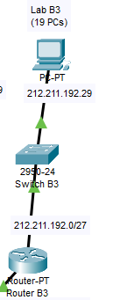 Each PC was given an IP address ending with 9 to make configuration easier and neater. Notes were used to help save time while setting up routes and testing for connectivity.

**Lab A3, 18 PCs** – 212.211.192.00**1**00000 - 5 Host bits needed, 32 addresses (30 usable) **(see Figure 3)**

**Subnet:** 212.211.192.32/27 (32-5)

**Subnet Mask:** 255.255.255.224

**Network Address:** 212.211.192.32

**Usable IPs**: 212.211.192.33 - 212.211.192.62

**Broadcast Address:** 212.211.192.63

Figure 3

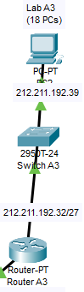

**Office C2, 16 PCs –** 212.211.192.0**10**00000 - 5 Host bits needed, 32 addresses (30 usable), 4 bits are not enough (16 addresses – 2 = 14 usable, not enough for 16 PCs) **(see Figure 4)**

**Subnet:** 212.211.192.64/27 (32-5)

**Subnet Mask**: 255.255.255.224

**Network Address:**  212.211.192.64

**Usable IPs:** 212.211.192.65 - 212.211.192.94

**Broadcast Address:** 212.211.192.95

Figure 4

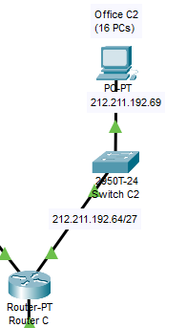

**Lab A1, 15 PCs –** 212.211.192.0**11**00000 - 5 Host bits needed, 32 addresses (30 usable), 4 bits are not enough (16 addresses – 2 = 14 usable, not enough for 15 PCs) **(see Figure 5)**

**Subnet:** 212.211.192.96/27 (32-5)

**Subnet Mask:** 255.255.255.224

**Network Address:** 212.211.192.96

**Usable IPs:** 212.211.192.97 - 212.211.192.126

**Broadcast Address:** 212.211.192.127

Figure 5

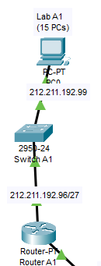

**Lab B1, 13 PCs –** 212.211.192.10000000 - 4 Host bits needed, 16 addresses (14 usable) **(see Figure 6)**

**Subnet:** 212.211.192.128/28 (32-4)

**Subnet Mask:** 255.255.255.240

**Network Address:** 212.211.192.128

**Usable IPs:** 212.211.192.129 - 212.211.192.142

**Broadcast Address:** 212.211.192.143

Figure 6

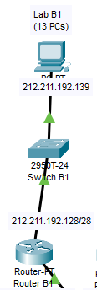

**Lab B2, 12 PCs –** 212.211.192.10010000 - 4 Host bits needed, 16 addresses (14 usable) **(see Figure 7)**

**Subnet:** 212.211.192.144/28 (32-4)

**Subnet Mask:** 255.255.255.240

**Network Address:** 212.211.192.144

**Usable IPs:** 212.211.192.145 - 212.211.192.158

**Broadcast Address:** 212.211.192.159

Figure 7

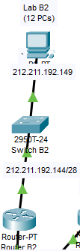

**Lab A2, 10 PCs-** 212.211.192.10100000 - 4 Host bits needed, 16 addresses (14 usable) **(see Figure 8)**

**Subnet:** 212.211.192.160/28 (32-4)

**Subnet Mask:** 255.255.255.240

**Network Address:** 212.211.192.160

**Usable IPs:** 212.211.192.161 - 212.211.192.174

**Broadcast Address:** 212.211.192.175

Figure 8

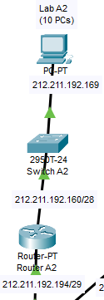

**Lab C1, 10 PCs –** 212.211.192.10110000 - 4 Host bits needed, 16 addresses (14 usable) **(see Figure 9)**

**Subnet:** 212.211.192.176/28

**Subnet Mask:** 255.255.255.240

**Network Address:** 212.211.192.176

**Usable IPs:** 212.211.192.177 - 212.211.192.190

**Broadcast Address:** 212.211.192.191

Figure 9

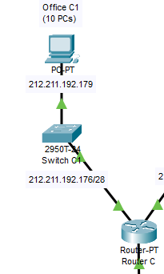

## 2.2 Richmond Site

### 2.2.1 Main Subnet for Richmond Site

These 3 routers **(see Figure 10)** lie in the same subnet, allowing them to communicate with each other. Each of them is connected to one another via a Switch-PT, in this case acting as a backbone. They were assigned IP addresses within the same range with a subnet mask of /29(255.255.255.248) which allows for 6 usable addresses. A mask of /30 would not suffice, since it only allows for 2 usable addresses, and in this case, we need 3. The IPs allocated to each of the router interfaces are:

**Router0**: 212.211.192.209, Interface Fa1/0

**Router1**: 212.211.192.210, Interface Fa1/0

**WAN Router1**: 212.211.192.211, Interface Fa0/0

Figure 10

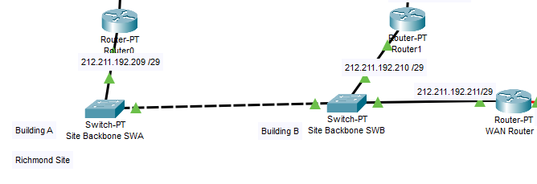

This subnet uses the network address 212.211.192.208, which follows the 212.211.192.200/29  
and 212.211.192.192/29 subnets. By assigning these subnets sequentially, a logical structure is maintained. Additionally, the design leave space within these existing subnets for potential future expansions. For instance, both the 212.211.192.192/29 and 212.211.192.200/29 ranges still have a small number of unused IPs available, ensuring that new devices can be added without requiring a complete reallocation of the IP addressing scheme. This particular subnet is what makes communication possible between Building A, Building B, and non-neighboring networks.

## 2.3 Building A

The routers A1, A2, and A3 are interconnected through a Switch-PT **(see Figure 11)**, which acts as the backbone for Building A. A subnet mask of /29(255.255.255.248) is used, which provides 6 usable addresses per subnet. The network address used is 212.211.192.192/29. This specific address is used because it is the next address free to use after Office C1’s IP address, which finishes at 212.211.192.191. This provides a smooth logical flow. This subnet allows for additional devices to be added to this network if needed, allowing for potential future expansions within the same subnet.

The IPs allocated to each of the router interfaces towards the building backbone are:

**Router0**: 212.211.192.196, Interface Fa3/1

**Router A1**: 212.211.192.193, Interface Fa1/0

**Router A2**: 212.211.192.194, Interface Fa1/0

**Router A3:** 212.211.192.195, Interface Fa1/0

Figure 11

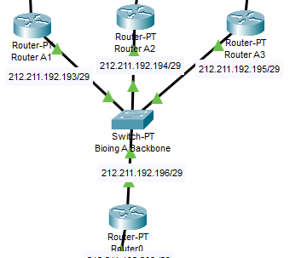

## 2.4 Building B

The routers B1, R2, and B3 are interconnected through a Switch-PT **(see Figure 12)**, which serves as the backbone for Building B. A subnet mask of /29 is used, providing 6 usable addresses per subnet. The network address used is 212.211.192.200/29. This subnet was chosen because it is the next available address after Building A's backbone subnet, which finishes at 212.211.192.199. This subnet allows for efficient use of addresses. The structure ensures that the routers can effectively communicate within Building B and route traffic to Building A or the WAN.  
  
The IP addresses are assigned as follows:

**Router1**: 212.211.192.205, Interface Fa0/0

**Router B1:** 212.211.192.202, Interface Fa1/0

**Router R2:** 212.211.192.203, Interface Fa1/0

**Router B3:** 212.211.192.204, Interface Fa1/0

Figure 12

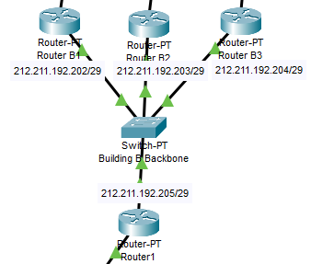

## 2.5 WAN Link (Leased Line)

The WAN connection between WAN Router 1 and WAN Router 2uses a dedicated subnet with a mask of /30 **(see Figure 13)**. This configuration provides exactly two usable IP addresses, ensuring efficient utilization for point-to-point links.

The network address used is 212.211.192.224/30, chosen because it is the next available subnet after previous allocations. By leaving some unused space between subnets, such as the .209/29 subnet, we allow for future expansion or the addition of devices to adjacent networks if needed.

Figure 13

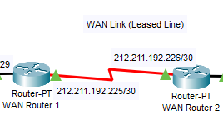

The IP addresses are assigned as follows:

**WAN Router 1**: 212.211.192.225, Interface Se2/0

**WAN Router 2**: 212.211.192.226, Interface Se2/0

**Broadcast Address:** 212.211.192.227

## 2.6 Surbiton Site

### 2.6.1 Surbiton Site Backbone

The Surbiton Site Backbone connects three routers—Router C, WAN Router 2, and the Domain Gateway Router—via a Switch-PT, which acts as the backbone for this part of the network **(see Figure 14)**. A subnet mask of /29 was used, providing 6 usable addresses per subnet. This ensures efficient address allocation while leaving room for potential device expansion if needed.

Figure 14

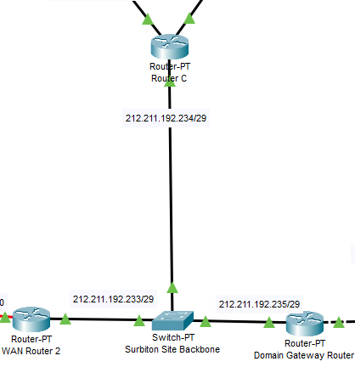

IP Address Allocation:

**Router C:** 212.211.192.234/29, Interface Fa1/0

**WAN Router 2:** 212.211.192.233/29, Interface Fa0/0

**Domain Gateway Router:** 212.211.192.235/29, Interface Fa0/0

Switch-PT Backbone: In this network configuration, this is a Layer 2 device and does not require an IP address.

The network address 212.211.192.232/29 was chosen because it is the next sequential block available after the WAN Router 2 link (212.211.192.226/30). To ensure a cleaner and more organized IP addressing scheme, a gap was intentionally left between the 226/30 and 232/29 subnets. This decision was made to align the starting addresses of major subnets with rounded or easily identifiable numbers. While this results in some unused addresses, it simplifies network visualization and troubleshooting by creating a more structured layout. The resulting scheme is both functional and easier to comprehend.

## 2.7 Internet Setup

The connection between the Domain Gateway Router and the Internet Core Router is established using the subnet **150.150.0.0/16 (see Figure 15)**. This subnet provides a large address range, ensuring future connections for devices or routers that need to be integrated into the global internet infrastructure. The Domain Gateway Router is assigned the IP address **150.150.0.1(Fa1/0)**, while the Internet Core Router uses **150.150.0.2(Fa1/0)** for its interface within this subnet. This clear and simple configuration enables seamless communication between the local network and the wider internet.

Figure 15

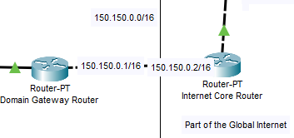

The Internet Core Router connects to the Internet Server using the **150.250.0.0/16** subnet. This large address space was chosen to allow many devices to connect to the network if needed. The Internet Core Router is assigned the IP address **150.250.0.1(Fa0/0)**, while the Internet Server is configured with the preassigned IP address **150.250.127.56**.

The server was preconfigured, meaning its IP address and subnet settings required no additional changes. The /16 subnet mask ensures a wide range of IP addresses is available for devices that will need to connect to the server in the future. This connection serves as the network’s primary gateway to the internet, enabling communication with external resources efficiently.

# 3. Static Routing Scheme

The network utilizes a static routing scheme to enable communication between the various subnets and the internet. Static routes were manually configured on all routers, specifying the next-hop IP address for each destination network. Below is an explanation of how the static routing scheme was implemented across all routers in the network. Additionally, the gateway of last resort was set to 150.250.127.56, ensuring that any packets destined for addresses outside the configured domain (i.e., the internet) are forwarded to the Internet Server.

## 3.1 Routers A1, A2, A3

For brevity, the configuration of Router A1 is shown here as an example **(see Figure 16)**. The configurations for Router A2 and Router A3 are identical, with only the interface IP addresses differing as per their respective network assignments.

**Purpose:** Connect Lab A1 to the rest of the network.

A static route was added to reach each subnet, including every router in building A, building B, the WAN Routers, every device in Sunbury site and the internet. The next-hop router for every destination from Router A is 212.211.192.196, which is Router 0. Router 0 then redirects all traffic either via Router1 or WAN Router 1, based on the destination.

Figure 16

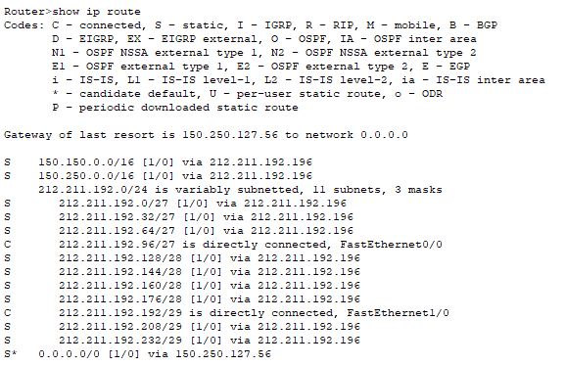

## 3.2 Router 0

**Purpose:** Connect Router 0 to the rest of the network.

A static route was set up to reach each subnet, such as Lab A2, Lab B1, The Internet Server, and Office C1 **(see Figure 17)**. The next-hop routers to reach the labs in its own subnet can be distinguished by the network address 212.211.192.192. In this case next-hop routers are 212.211.192.19x to reach each router from Lab A respectively. Traffic destined for Building B is routed through Router1, with an IP of 212.211.192.210, which is the interface facing Router0 non-directly through the Site Backbones. All traffic destined to reach the internet and Sunbury site is routed through WAN Router 1, with an IP of

212.211.192.211.

Figure 17

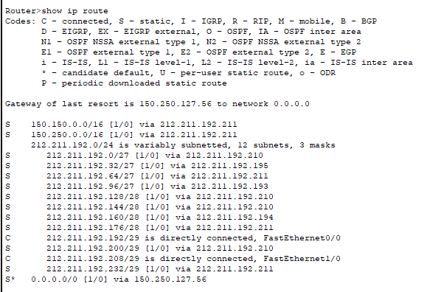

## 3.3 Routers B1, B2, B3

For brevity, the configuration of Router B1 is shown here as an example **(see Figure 18)**. The configurations for Router B2 and Router B3 are identical, with only the interface IP addresses differing as per their respective network assignments.

**Purpose:** Connect Router B1 to the rest of the network. Routing was performed the same way as for Router A1, however through its respective next hops. Router B1 is connected to each other router in its own subnet, and non-neighboring subnets through Router1’s interface, which is clearly provided as 212.211.192.205. Routing inside the subnet **could** be set up so Router B1 connects directly to Routers B2 and B3 through their interfaces, without having to route through Router1. However, there is no difference in the response time and delay when pinging routers B2 and B3 from B1 through Router1, thus routing everything through Router1 makes routing clearer and neater, without any downsides to it such as delays. The same type of routing was performed for routers A1, A2 and A3 through Router0.

Figure 18

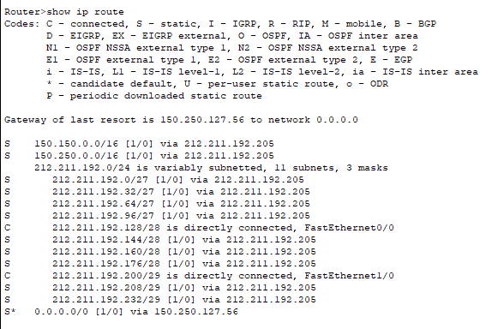

## 3.4 Router 1

**Purpose:** Connect Router 1 to the rest of the network **(see Figure 19)**.

A static route was set up to reach each subnet, such as Lab A2, Lab B1, The Internet Server, and Office C1. The next-hop routers to reach the labs in its own subnet can be distinguished by the network address 212.211.192.200. In this case next-hop routers are 212.211.192.202-204 to reach each router from Lab B respectively. Traffic destined for Building A is routed through Router0, with an IP of 212.211.192.209, which is the interface facing Router1 non-directly through the Site Backbones. All traffic destined to reach the internet and Sunbury site is routed through WAN Router 1, with an IP of

212.211.192.211.

Figure 19

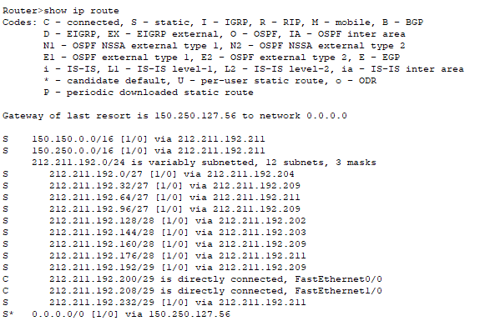

## 3.5 WAN Router 1

**Purpose:** Connect WAN Router 1 to the rest of the network **(see Figure 20).**

WAN Router 1 is an integral component of the network, serving as the bridge between Building B's internal network and the external networks, including the Sunbury site and the global Internet. Its primary role is to ensure that all traffic from Building B and downstream networks can be efficiently routed to their intended destinations.

Figure 20

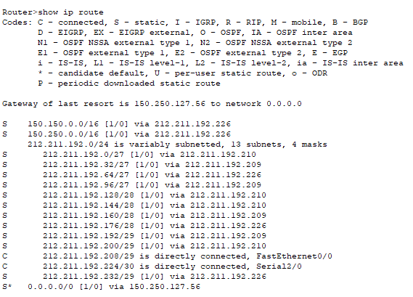

The router's interface toward the Site Backbone SWB is configured with the IP address 212.211.192.211/29, which connects it to the Building B internal network through the backbone switch, using Router1’s interface (212.211.192.210). The WAN interface connecting to WAN Router 2 is assigned the IP address 212.211.192.225/30, forming a point-to-point link between the two routers. Routes are configured to direct packets destined for Building B's internal subnets, such as Lab B1 (212.211.192.128/28) and Lab B2 (212.211.192.144/28), through 212.211.192.210.

Traffic destined for the global Internet is routed through WAN Router 2 at 212.211.192.226. A gateway of last resort is set to the Internet Server, with the next hop configured through WAN Router 2. This ensures that all external traffic is forwarded efficiently toward the global Internet.

## 3.6 Wan Router 2

**Purpose:** Connect WAN Router 2 to the rest of the network **(see Figure 21)**.

WAN Router 2 allows connection from Router C and the Domain Gateway router via Surbiton Site Backbone, facilitating the flow of traffic between the Sunbury site, Richmond site, and the global Internet.

The interface facing WAN Router 1 is assigned 212.211.192.226/30, forming a point-to-point link for inter-site communication. The interface toward the Surbiton Site Backbone uses 212.211.192.233/29, and the interface to the Domain Gateway Router is configured with 212.211.192.235/29.

A gateway of last resort is configured with the next hop (212.211.192.235) to the Internet Server (150.250.127.56). Static routes direct traffic to internal subnets via WAN Router 1, or the Surbiton Backbone. WAN Router 2 ensures efficient routing for both local and external destinations.

Figure 21

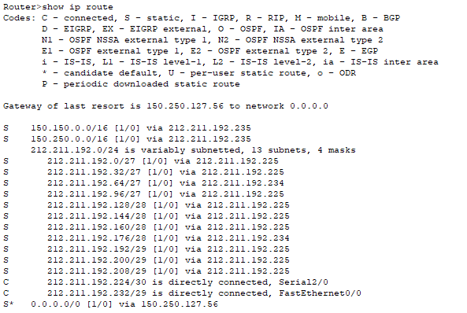

## 3.7 Domain Gateway Router

**Purpose:** Connect the Domain Gateway Router to the rest of the network **(see Figure 22)**.

The Domain Gateway Router serves as the connection point between the internal network and external internet connectivity. It is connected to three networks: the Surbiton Site Backbone, the 150.150.0.0/16 subnet, and the 150.250.0.0/16 subnet. These connections enable communication within the domain and external global networks.

The FastEthernet0/0 interface is connected to the Surbiton Site Backbone, assigned the IP 212.211.192.235/29, it allows for routing towards the WAN2 router and Router C. Routing towards the WAN2 router allows for further routing towards the Richmond site (Building A and Building B)

The FastEthernet0/1 interface is connected to the 150.150.0.0/16 network, using the IP 150.150.0.1. This connection acts as the main uplink to the core internet infrastructure, allowing devices in the domain to access external services.

The default gateway for the Domain Gateway Router is set to 150.250.127.56, the preconfigured internet server. This ensures that all packets destined for external networks are forwarded through the core internet router.

Figure 22

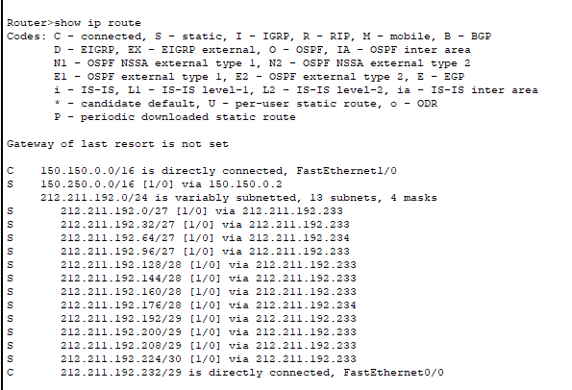

## 3.8 Internet Core Router

Purpose: Connect the Internet Core Router to the rest of the network **(see Figure 23)**.

The Internet Core Router is the final step in the network that connects the entire domain to the global internet. Its primary function is to route packets between the domain's internal networks and external networks, including the Internet Server.

A static route was set up to reach each subnet allowing for every single device to reach the internet server through the Internet Core Router. All static routes towards the Sunbury and Richmond site pass through the interface of the Domain Gateway Router (150.150.0.1) and are then routed towards either Router C (212.211.192.234) or the WAN Router 2(212.211.192.233), which acts as the bridge towards the Richmond site.

A gateway of last resort is set to the Internet Server’s IP, ensuring that any packets with unknown destinations outside of the 150.250.0.0/16 and 212.211.192.0/24 are routed to the Internet Server.

Figure 23

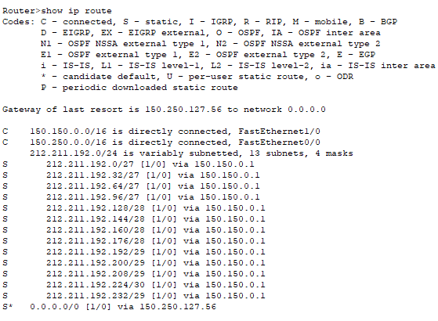

# 4. Testing And Evaluation

To verify connectivity across the network, testing will be performed by pinging from the PC in Lab A1, and the PC in Lab B1 to the IP address of every other PC. This will confirm that all static routes are correctly configured and that all subnets are accessible.

To ensure that all hosts in the network can access the internet, I will test connectivity by accessing a web page hosted on the internet server using its IP address. This will verify that the gateway of last resort is correctly configured and that external communication beyond the local network is operational.

## 4.1 PC0 to all PCs

### 4.1.1 PC0 to Lab A2 PC1, Lab A3 PC2, Lab B1 PC3 **(see Figure 24)**

Figure 24

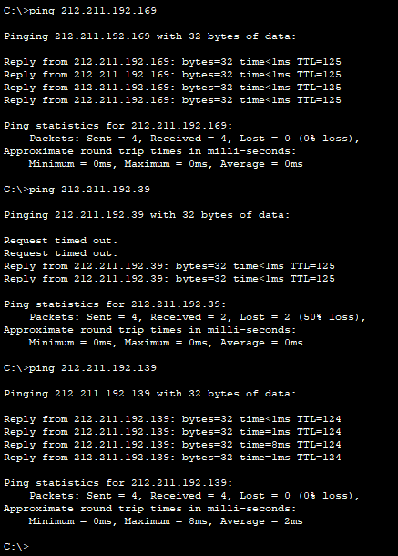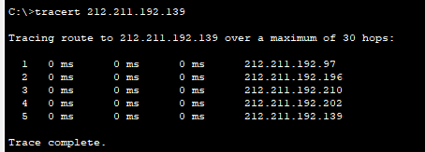

### 

### 4.1.2 PC0 to Lab B2 PC4, Lab B3 PC5, Office C1 PC3(1), Office C2 PC4(1) **(see Figure 25)**

Figure 25

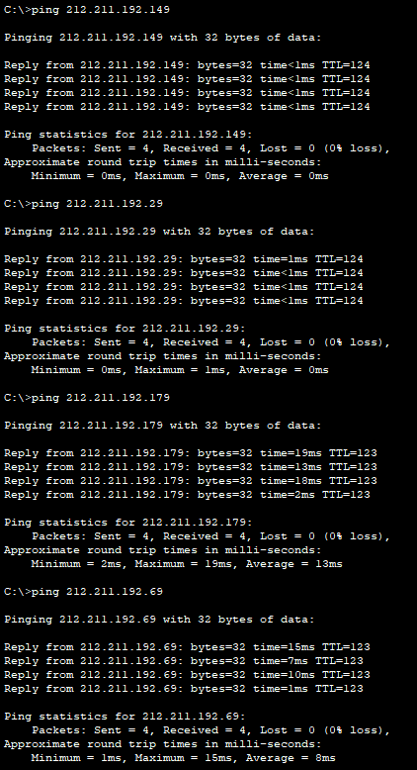

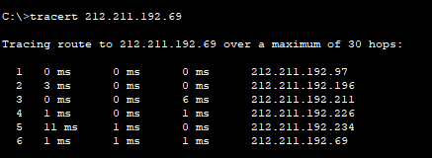

## 4.2 PC3 to all PCs

### 4.2.1 PC3 to Lab A1 PC0, Lab A2 PC1, Lab A3 PC2, Lab B2 PC4 **(see Figure 26)**

Figure 26

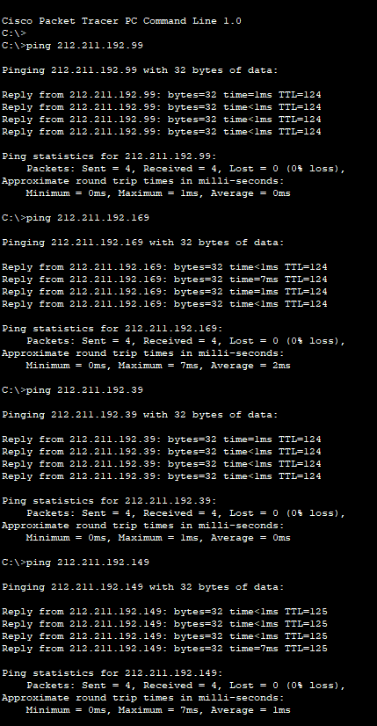

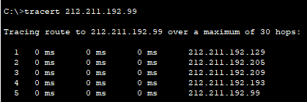

### 4.2.2 PC3 to Lab B3 PC5, Office C1 PC3(1), Office C2 PC4(1) **(see Figure 27)**

Figure 27

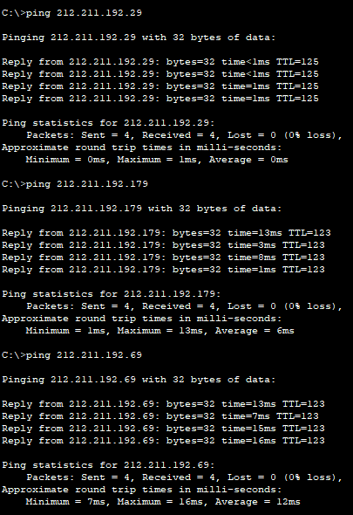

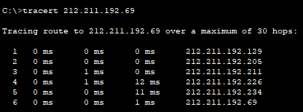

## 4.3 Each PC able to access the internet via web page

### 4.3.1 All PCs in Building A reach the web **(see Figure 28,29,30)**

Figure 28

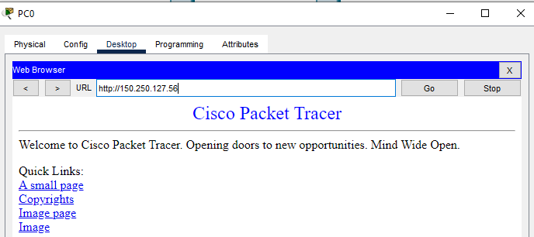

Figure 29

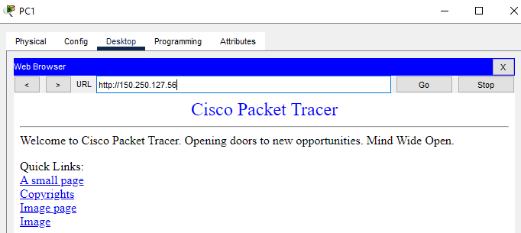

Figure 30

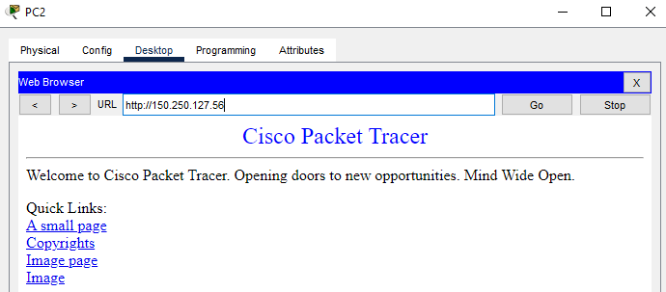

### 4.3.2 All PCs in Building B reach the web **(see Figures 31,32,33)**

Figure 31

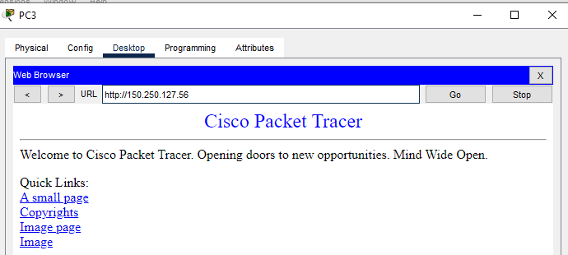

Figure 32

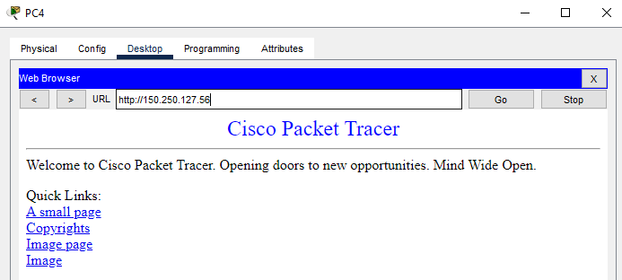

Figure 33

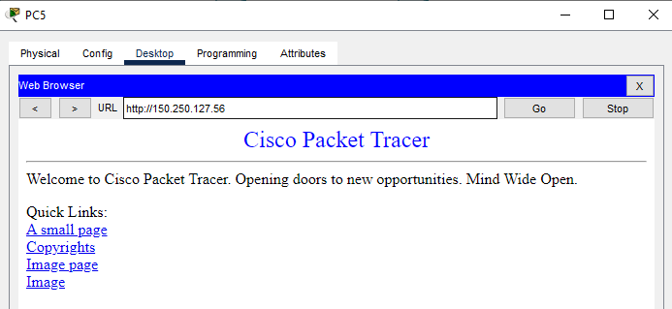

### 4.3.3 Sunbury Site

#### 4.3.3.1 Both PCs in Sunbury site can reach the web **(see Figures 34,35)**

Figure 34

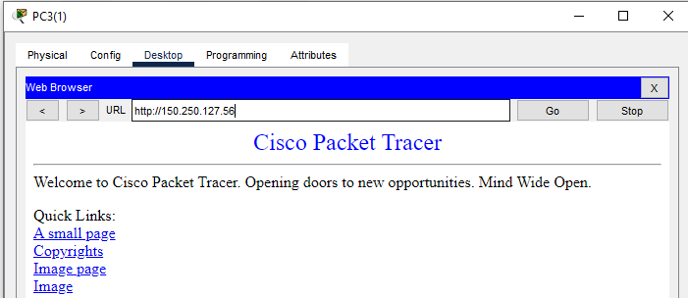

Figure 35

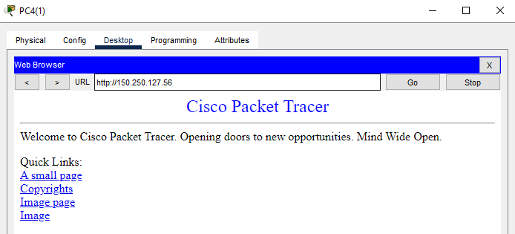

# 5. Conclusion

In conclusion, this project involved designing and configuring a complex network with multiple subnets and routing mechanisms to ensure seamless connectivity between all devices and access to the internet. Through the use of subnetting, IP addressing, and static routing, each segment of the network was interconnected while maintaining efficiency and scalability. The configuration of routing tables and the gateway of last resort allowed for communication across different networks and access to external resources. Testing and evaluation confirmed the successful implementation of the network, with all hosts able to communicate with each other and access the internet server. This project demonstrated the importance of careful planning, structured configuration, and thorough testing in creating a functional and reliable network.